What did you do?
To research the security of my accounts and computer system, I used two well-known cybersecurity tools: Have I Been Pwned (HIBP) and ShieldsUP!!.
Have I Been Pwned
First, I checked my email address on HIBP to see if it had been exposed in any known data breaches. This service works by comparing the submitted email against a large database of leaked credentials collected from past breaches. If an email shows up, it means it was part of a data dump accessible to attackers.
Next, I checked a password I use to confirm whether it had ever been compromised in breaches. HIBP does this securely using a partial hash lookup method called k-anonymity, meaning my full password is never sent over the internet. Instead, only part of its hash is compared to the database, ensuring both privacy and accuracy.
ShieldsUP!!
I tested the security of my computer’s network ports. ShieldsUP!! scans a range of ports (in this case, the first 1056 TCP ports) to determine if they are:
Open: Accessible and potentially vulnerable to attackers.
Closed: Not in use but still visible to the outside world.
Stealth: Hidden, giving no response to probes, which is the most secure option.
The tool also ran a TruStealth Analysis, which simulates how my system would appear to hackers scanning for weaknesses. Essentially, this shows if my system is completely invisible to unsolicited traffic from the internet.
By using both HIBP and ShieldsUP!!, I combined account security research (whether my credentials are exposed) with system/network security testing (whether my PC is leaking vulnerabilities through open ports).

What were the results?
The results were very positive and reassuring:
Have I Been Pwned
Email Result: My email address (igwezebenji@gmail.com) showed 0 data breaches. This means it has not appeared in any known breach databases indexed by HIBP.
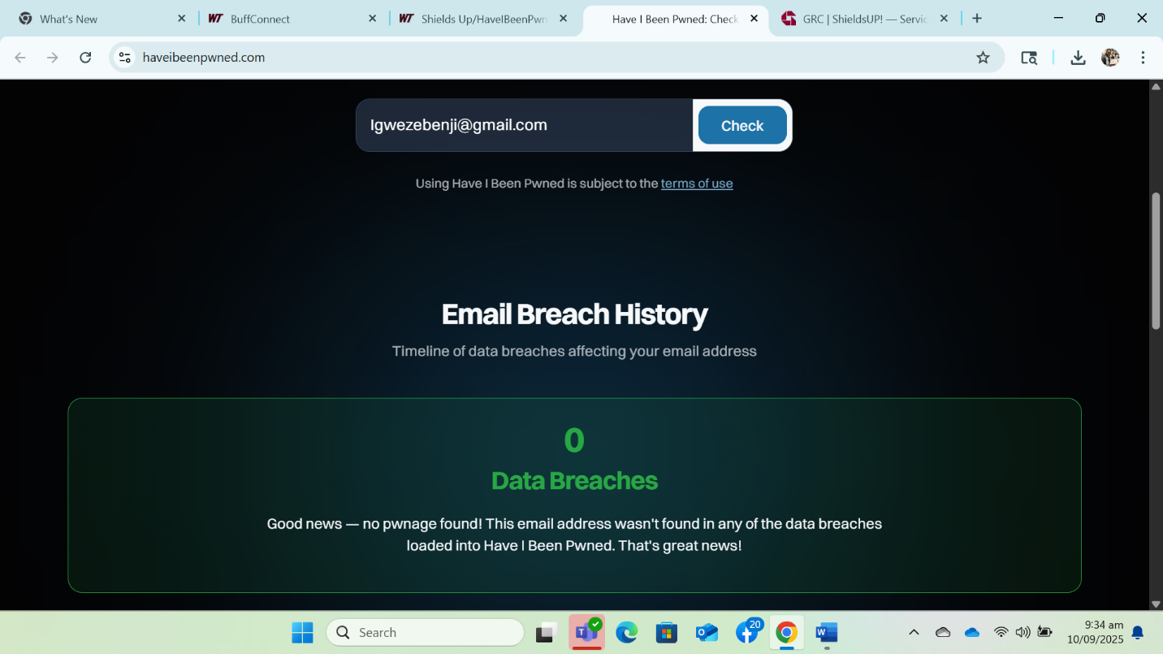
Password Result: The password I tested also returned no matches in the Pwned Passwords database. This indicates it has not been exposed in known breaches.
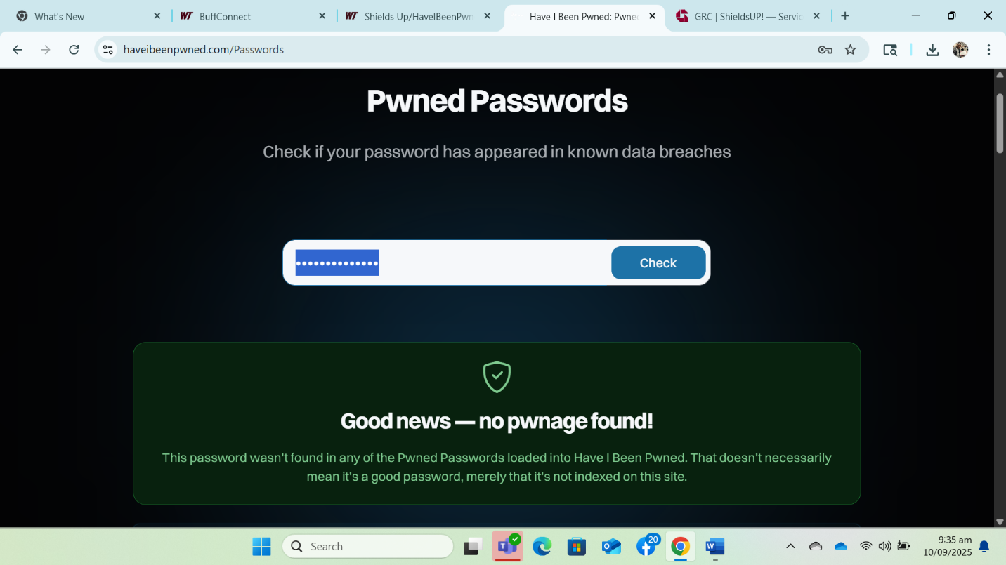

ShieldsUP!!
The port scan showed all 1056 tested ports in Stealth mode (green) and I got the following reports
All Ports Scan (first 1056 ports)
- Every one of the 1056 tested ports returned a Stealth result.
- This means my system provided no response whatsoever to connection attempts. To an external attacker, it looks as though my computer does not exist at all.
- The “TruStealth Analysis” summary confirmed a perfect TruStealth rating:
- Not a single packet was received from my system.
- ICMP echo requests (pings) were ignored.
- To hackers scanning the internet, my IP appears completely silent.
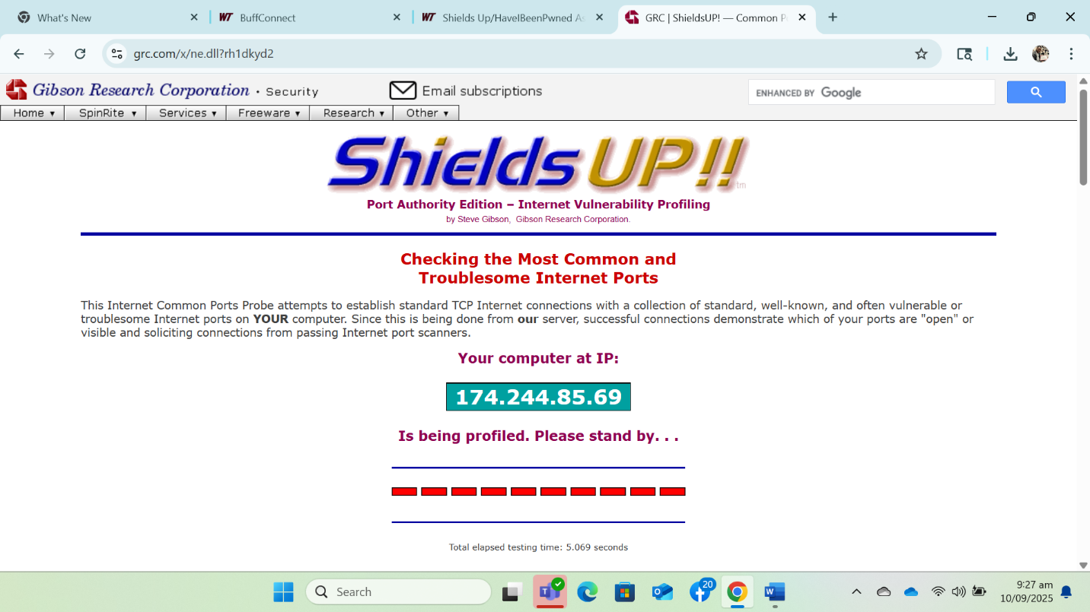

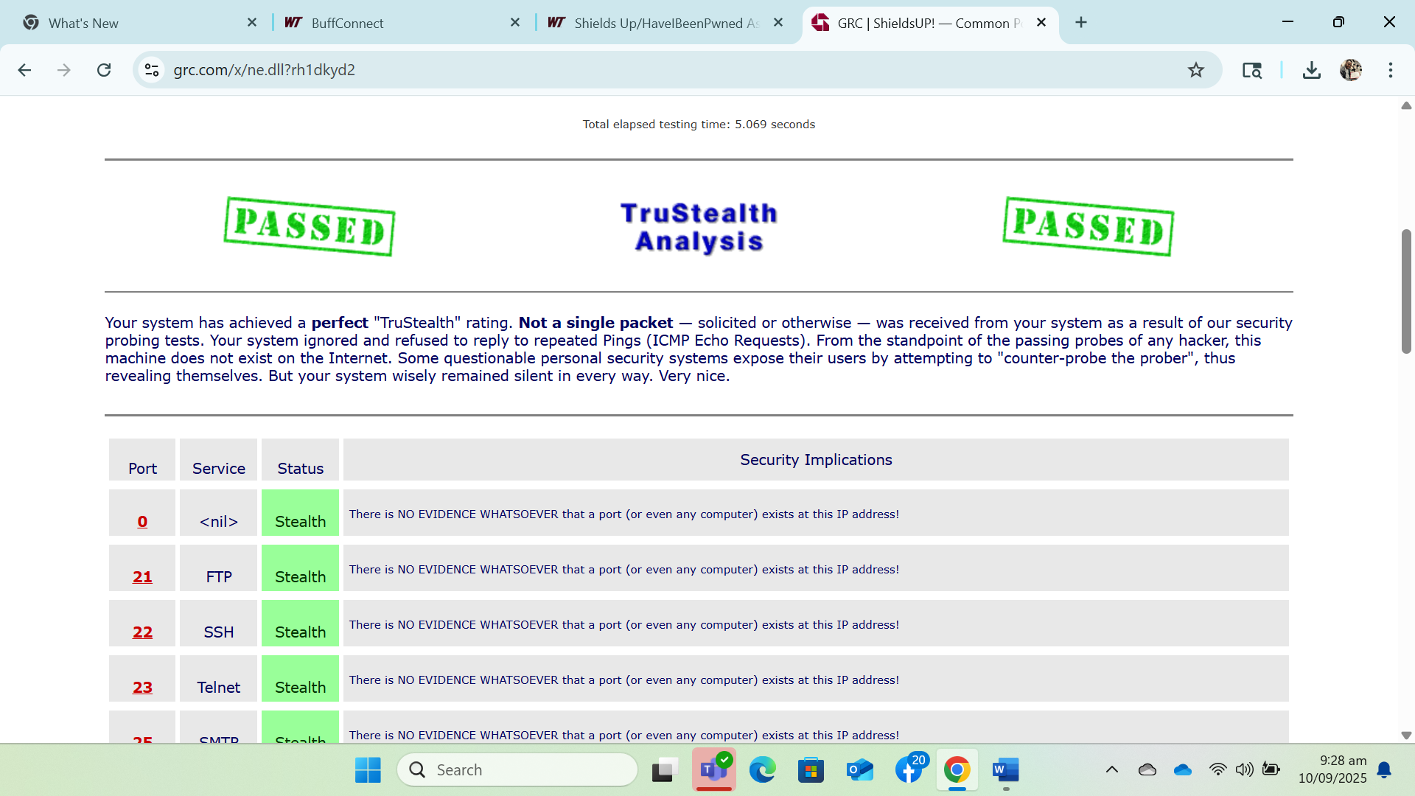
Common Ports Scan
Ports tested included FTP (21), SSH (22), Telnet (23), SMTP (25), HTTP (80), and others.
  - Each of these ports also returned Stealth. For example:
- Port 21 (FTP): Stealth → no evidence that FTP exists on this IP.
- Port 22 (SSH): Stealth → hidden from detection.
- Port 23 (Telnet): Stealth → completely invisible.
- Port 25 (SMTP): Stealth → no sign of mail service running.
  - ShieldsUP!! confirmed: “There is NO EVIDENCE WHATSOEVER that a port (or even any computer) exists at this IP address!”
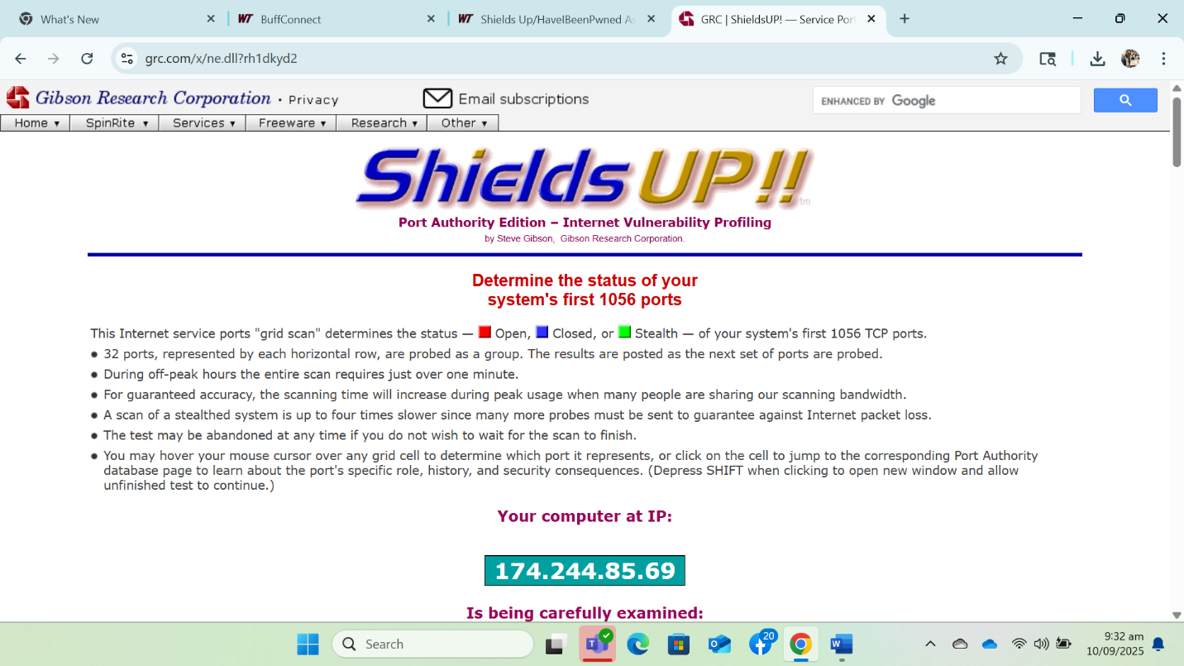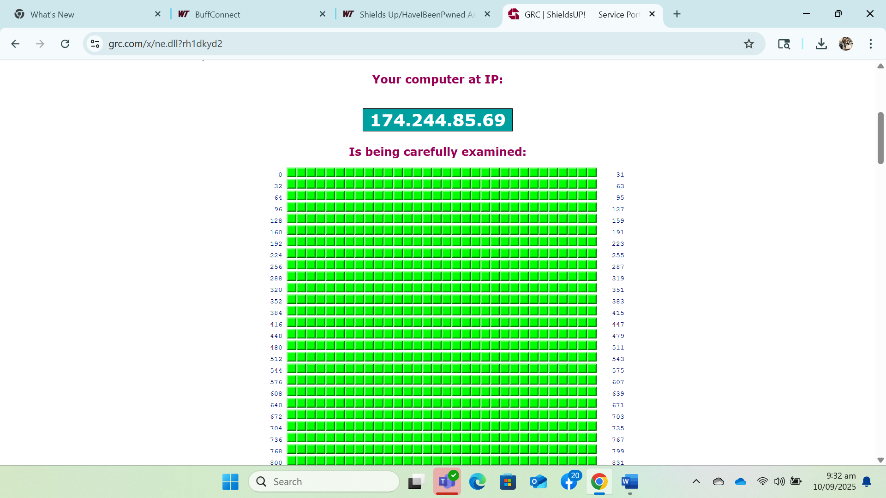

What did you learn?
Several insights came from this exercise:
- Security is multi-layered
- Checking my email and passwords against breaches showed that my personal credentials are not currently exposed, which reduces my risk of credential-stuffing attacks.
- Running a port scan with ShieldsUP!! reinforced that system security goes beyond passwords; a secure system also requires hiding or securing network entry points (ports).
- Stealth is stronger than “closed”
- Before this, I assumed a “closed” port was good enough. However, I learned that closed ports still acknowledge their existence to scanners, which can encourage attackers to keep probing.
- A stealth port, by contrast, gives no response at all — making the system invisible. This “security by obscurity” is not the only defense, but it is an excellent first line of defense.
- Privacy-preserving tools exist
- The way HIBP checks passwords using k-anonymity was eye-opening. I realized that you could check sensitive data securely without actually giving away the data itself. This has implications beyond passwords — it shows a model for privacy-conscious security tools.
- Personal reflection
- My biggest “aha” moment was realizing that even if my credentials are safe today, breaches can happen at any time. Security is not a one-time check but a continuous process. I should regularly monitor my accounts with HIBP and test my system with tools like ShieldsUP!! to stay ahead of new threats.
- I also saw a crossover to project management and IT infrastructure: just as we continuously monitor KPIs in projects, we must also continuously monitor digital security metrics to protect systems and data.

